**Subject: Gordon Propst Interview Questions and Answers**  
  
**Interview Questions:**

What is your full name?

**Gordon Meade Propst – Middle name “Meade”… the drink. I love to drink.**

Can you provide a brief overview of your background and career?

**I was born in Jennings, but I have lived most of my life in Lake Charles, Louisiana – Geaux TIGERS!!! I am a proud 1964 graduate of Lake Charles High School and went on to receive my bachelor's degree from McNeese State University.**

**After graduation from McNeese, I was commissioned as a second lieutenant in the U.S. Army.**

**I obtained a Juris Doctorate Degree from Louisiana State University and practiced law in Lake Charles briefly. I became the top administrator at Robinswood School for the Physically and Mentally Challenged from 1972 to 2020. I have served as a past president of the Lake Charles Jaycees and a member of Rotary International.**

**I was married for many years to the love of my life, who passed away in 2009. And found a new life and comfort in the gay community.**

**Now, I spend all of my free time surrounded by my friends and chosen family, traveling the world with you, Shane.**

What are your hobbies and interests?  
  
**Drinking and meeting new people - I have never met a stranger.**

**Traveling the world with Shane – I met Shane many years ago and had never traveled internationally outside of Mexico. Shane allowed me to join him on a trip to Europe, and we spent the next decade traveling to far-reaching parts of the world until the pandemic got in our way!   
  
I collect graphic T-shirts- I can’t help buying shirts at every location and event I am at!**

Are there any significant goals or achievements in your life?

**I became good friends with a family in Mexico over the years and became Godfather to one of them. My Goddaughter is a joy to me, and seeing her graduate college recently was one of my greatest joys.**

**In addition, I have been lucky to have two great loves in my life, both Angie and you, Shane. I just love you so DAMN much, KID!**

How do you spend your free time?

**Planning our next trip. Visiting with friends on the internet that I have made around the world.**

What motivates you in your personal and professional life?

**Margaritas, Friends- Seeing you, Shane. And, I love my puppies.**

Can you share a memorable experience or accomplishment?

**I love to eat, and we have been to some of the most amazing restaurants in the world. Long conversations with friends over good food.**

What values are important to you?

**"Joie de vivre" is a French phrase that means "joy of living." English speakers often use it to describe someone who enjoys life in a cheerful and spirited way.**

Do you have any favorite quotes or mottos?

**“Fuck it! – It’s Just Money.”**

**“There’s always time for a cocktail.”**

**“I feel six-teen, I am going to live to be 100.”**

How would you like to be portrayed on the website?

**I’ll leave that up to you, Shane. You know I am shy.**

**Short Bio/Remembrance:**

My dear friend [Gordon Propst](https://www.facebook.com/profile.php?id=100006287655698&__cft__%5b0%5d=AZXwFUNipm1Lwb7njPWX1iAYttQrfDxdmXorR-aKwmwvyMbq5iAq-cLFGwCtfXrbBB6BgnyJpSJFPJGFeuslbaHtHbl-y0OeTUFH6vkbHrIxLJWAEjFwwnRdtakK1VqWZNLZd7P9-2TRPX96yWA5yX5jc4rNq8ZADzY14sZ27L6hTg&__tn__=-%5dK-R), I will miss you so much. You were one of the few people in my life who just understood me from the moment we met. We met by chance, and it was a party from that moment on.

Life with Gordon wasn't just a party; it was a grand, messy Carnival, laughter bubbling over with adventure tucked around every corner. Traveling the world and adventure were his treasure troves. Gordon and I shared many adventures together in many countries and spent long nights discussing promising future escapades...

But the treasures Gordon collected weren't just graphic tee-shirts and trinkets on his adventures. The real treasures were the people and connections he made with them. He saw the sparkle in everyone's eyes, the potential friend where others saw just a face in the crowd. And wouldn't you know it, he was usually right. Many of the relationships that I value today are relationships that he helped build. His smile was like a magnet, drawing you in with its warmth and genuine interest.

Gordon’s kindness and generosity were unsurpassed in this world. He was eternally optimistic and never complained about anything, even when he was going through the darkest of times. He found joy in the smallest of moments.

Although I don’t drink anymore, I will sit with a margarita on the rocks and order one on occasion just for you.

Gordon was my family when I had none. He would always say, “I just love you so damn much, KID!” And I knew it was true. We shared a love that few people will ever know.

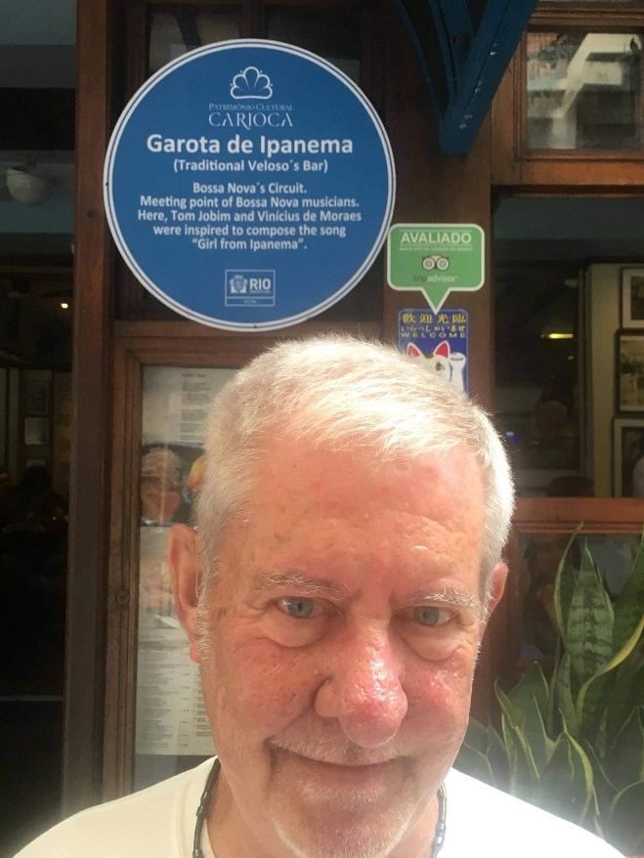**First Time In Europe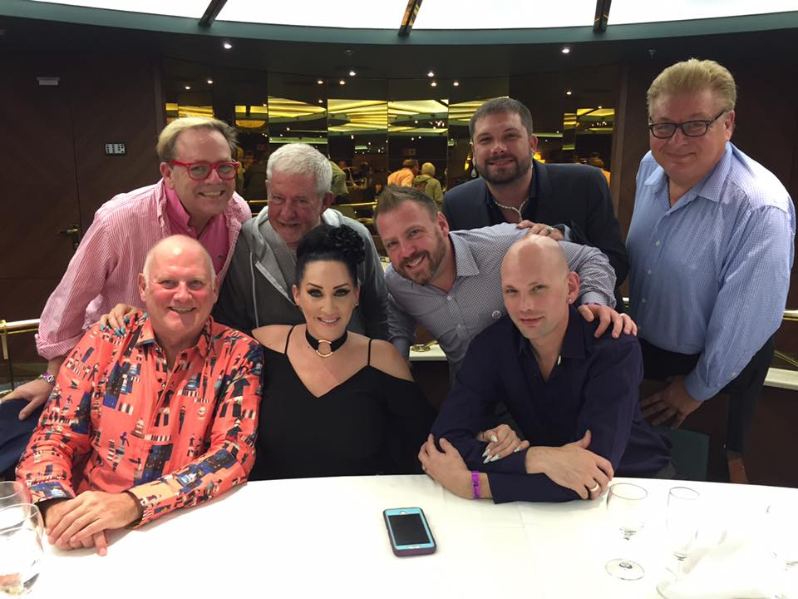Eating with old and new friends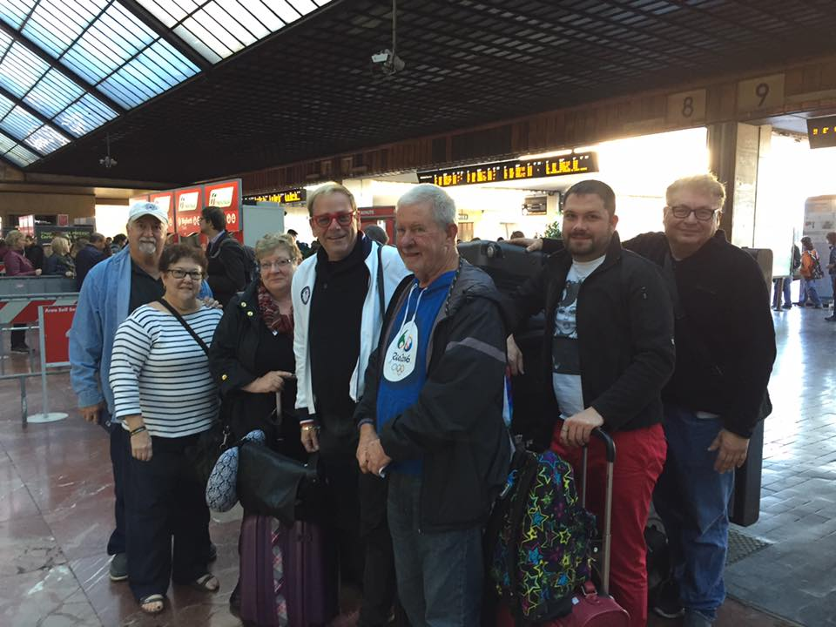Second Time In Europe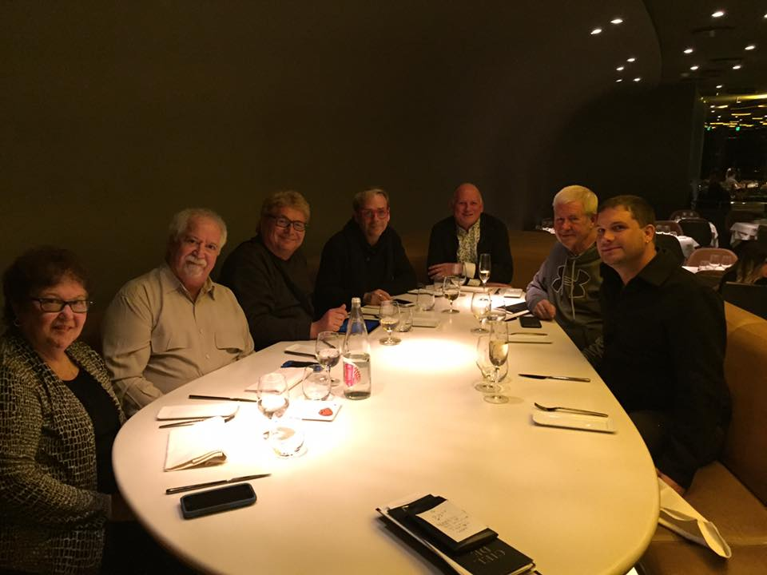Dinner at nice resturants**

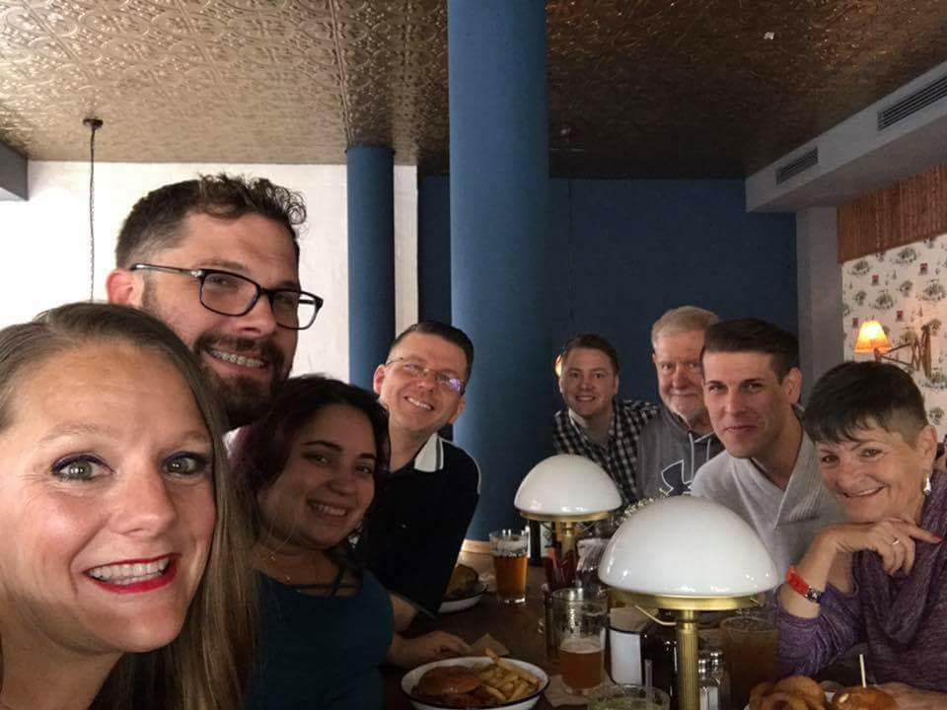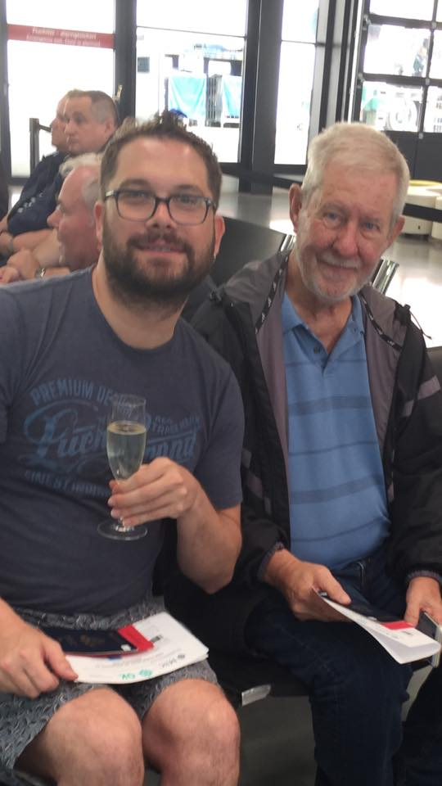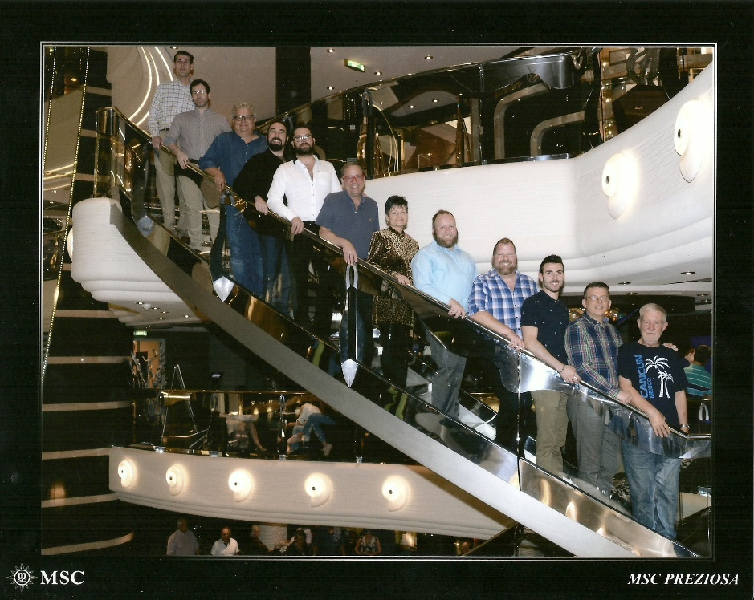**Chosen Family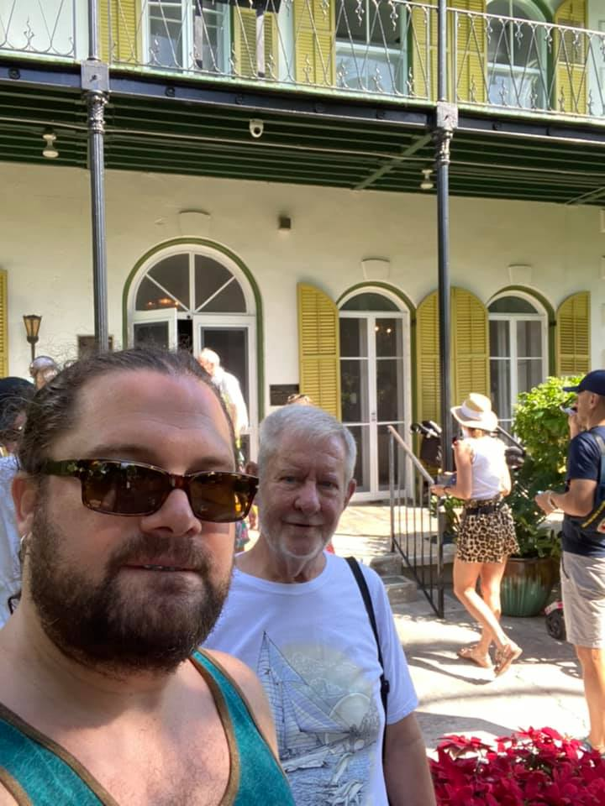Gordon Loved The French Quarter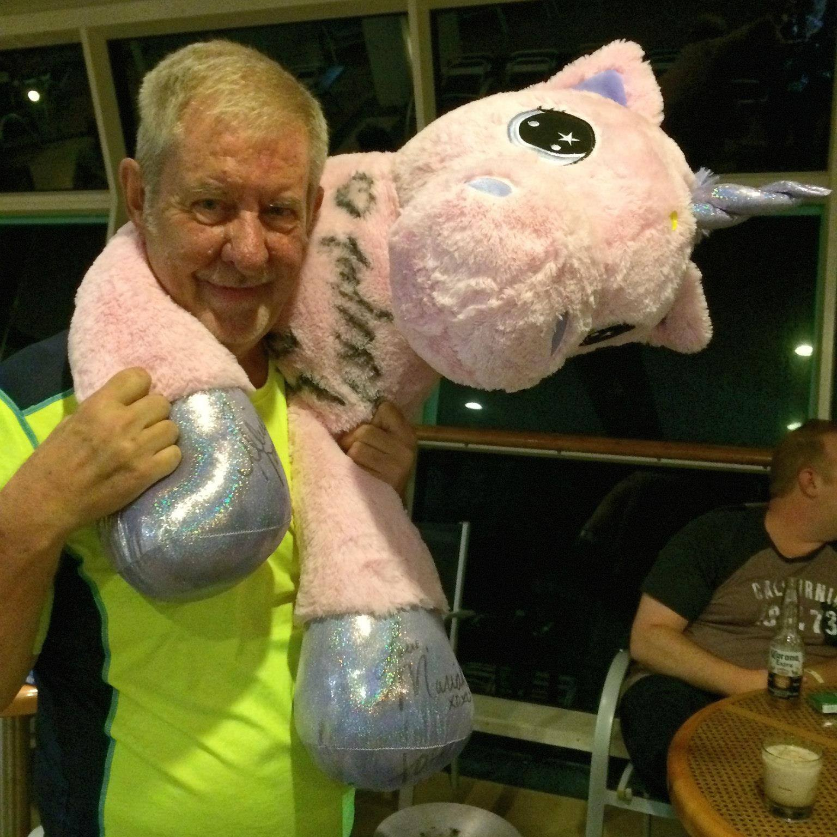  
Gordon loved charitable auctions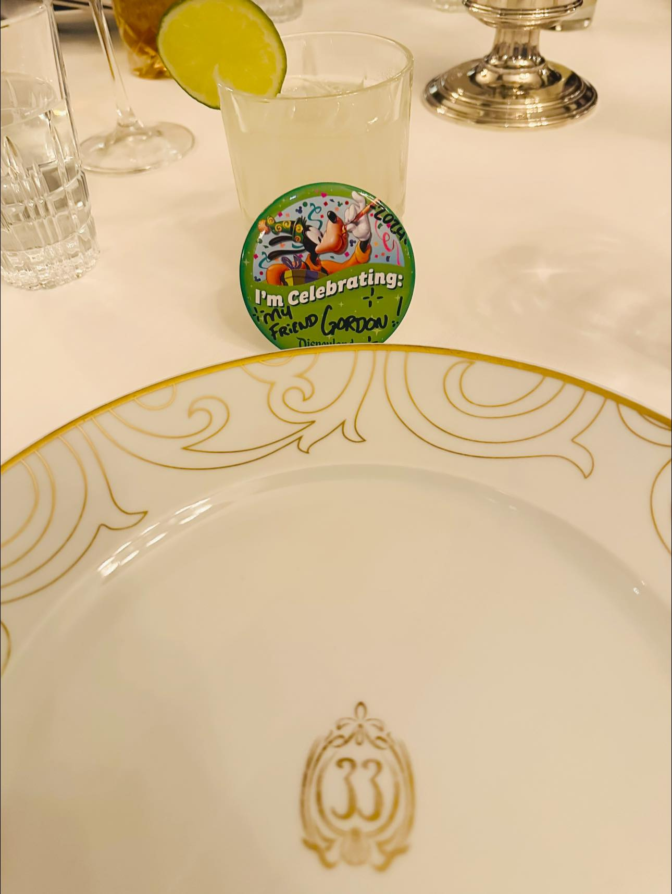  
Shane Celebrates Gordon At Amazing Resturant After Funeral  
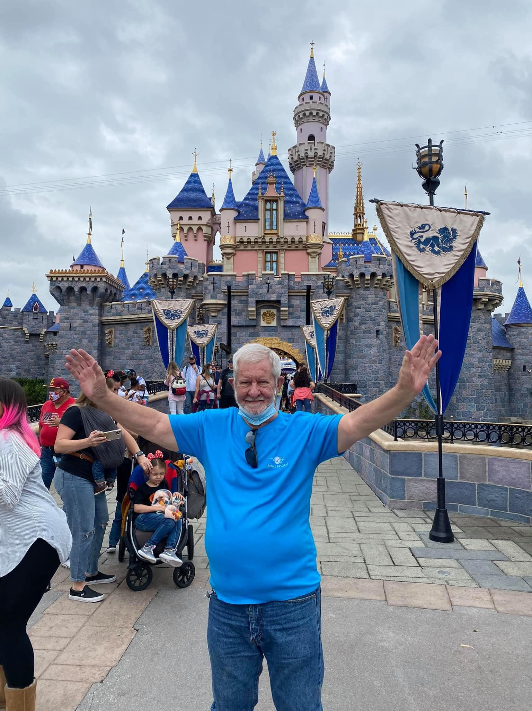Gordon Visits Disneyland after first time in 50 Years With Shane**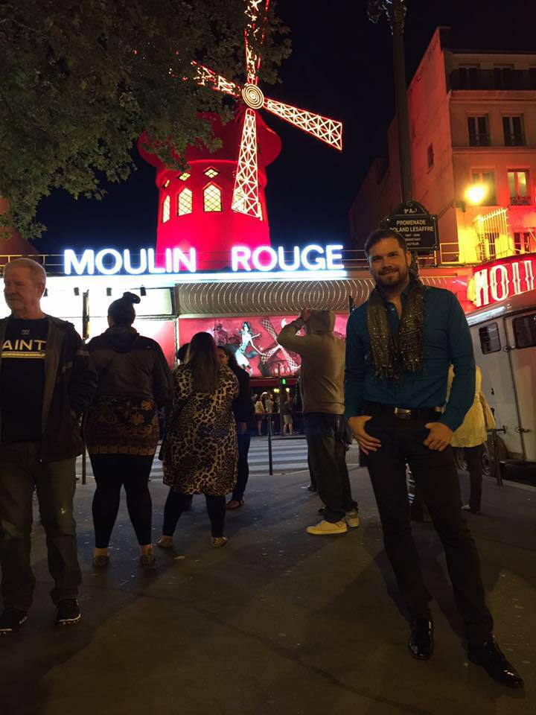

**Gordon and his Goddaughter**

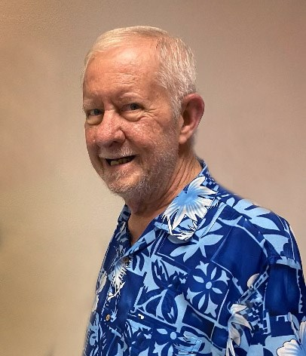

**Gordon’s Last Picture**

**Front-end Style Guides:**[**https://24ways.org/2011/front-end-style-guides/**](https://24ways.org/2011/front-end-style-guides/)

**Style Guide Components:**

1. **Color Palette:**

Example:

- Tailwind

{ 'pale_dogwood': { DEFAULT: '#e6beae', 100: '#3e1f13', 200: '#7b3e26', 300: '#b95d39', 400: '#d38c6f', 500: '#e6beae', 600: '#ebcabd', 700: '#f0d7ce', 800: '#f5e5de', 900: '#faf2ef' }, 'tiffany_blue': { DEFAULT: '#a9dad0', 100: '#173630', 200: '#2f6d60', 300: '#46a390', 400: '#73c3b3', 500: '#a9dad0', 600: '#bae2da', 700: '#cce9e3', 800: '#ddf0ec', 900: '#eef8f6' }, 'periwinkle': { DEFAULT: '#dcd6ff', 100: '#0e005e', 200: '#1c00bc', 300: '#3d1bff', 400: '#8d78ff', 500: '#dcd6ff', 600: '#e3deff', 700: '#eae7ff', 800: '#f1efff', 900: '#f8f7ff' }, 'night': { DEFAULT: '#0d160b', 100: '#020402', 200: '#050804', 300: '#070c06', 400: '#0a1008', 500: '#0d160b', 600: '#32542a', 700: '#58944a', 800: '#8bbf7f', 900: '#c5dfbf' }, 'mauve': { DEFAULT: '#baa5ff', 100: '#140054', 200: '#2700a7', 300: '#3b00fb', 400: '#7850ff', 500: '#baa5ff', 600: '#c7b6ff', 700: '#d5c8ff', 800: '#e3daff', 900: '#f1edff' } }

- CSV

e6beae,a9dad0,dcd6ff,0d160b,baa5ff

- With #

#e6beae, #a9dad0, #dcd6ff, #0d160b, #baa5ff

- Array

["e6beae","a9dad0","dcd6ff","0d160b","baa5ff"]

- Object

{"Pale Dogwood":"e6beae","Tiffany Blue":"a9dad0","Periwinkle":"dcd6ff","Night":"0d160b","Mauve":"baa5ff"}

- Extended Array

[{"name":"Pale Dogwood","hex":"e6beae","rgb":[230,190,174],"cmyk":[0,17,24,10],"hsb":[17,24,90],"hsl":[17,53,79],"lab":[80,12,13]},{"name":"Tiffany Blue","hex":"a9dad0","rgb":[169,218,208],"cmyk":[22,0,5,15],"hsb":[168,22,85],"hsl":[168,40,76],"lab":[84,-18,0]},{"name":"Periwinkle","hex":"dcd6ff","rgb":[220,214,255],"cmyk":[14,16,0,0],"hsb":[249,16,100],"hsl":[249,100,92],"lab":[87,10,-19]},{"name":"Night","hex":"0d160b","rgb":[13,22,11],"cmyk":[41,0,50,91],"hsb":[109,50,9],"hsl":[109,33,6],"lab":[6,-6,5]},{"name":"Mauve","hex":"baa5ff","rgb":[186,165,255],"cmyk":[27,35,0,0],"hsb":[254,35,100],"hsl":[254,100,82],"lab":[73,26,-42]}]

- XML

<palette>

<color name="Pale Dogwood" hex="e6beae" r="230" g="190" b="174" />

<color name="Tiffany Blue" hex="a9dad0" r="169" g="218" b="208" />

<color name="Periwinkle" hex="dcd6ff" r="220" g="214" b="255" />

<color name="Night" hex="0d160b" r="13" g="22" b="11" />

<color name="Mauve" hex="baa5ff" r="186" g="165" b="255" />

</palette>

1. **Typography:**

## Images

- Border: 2px solid #CCCCCC

- Shadow: 4px 4px 8px #888888

## Icons

- Icon Size: 24px

**Future Ideas: Create Pattern Library**

Implement the concepts of Atomic Design to develop a pattern library. This will ensure consistency in design elements across the website.  
  
1. Atoms:

Atoms are the basic building blocks of your design. These include things like colors, fonts, and simple UI elements.

Example Atoms:

Color Atom:

**EXAMPLES ONLY BELOW NOT TO BE USED AS LIVE CONTENT**

Primary Color: #3366CC

Secondary Color: #66CC99

Accent Color: #FF9900

Typography Atom:

Heading Font: [Font Name], Size: 36px, Weight: Bold

Body Font: [Font Name], Size: 16px, Weight: Regular

2. Molecules:

Molecules are combinations of atoms that form simple UI components.

Example Molecules:

Button Molecule:

Primary Button: Background Color - #3366CC, Text Color - #FFFFFF

Secondary Button: Background Color - #66CC99, Text Color - #333333

Form Input Molecule:

Text Input: Border - 1px solid #333333, Padding - 8px

Submit Button: Background Color - #FF9900, Text Color - #FFFFFF

3. Organisms:

Organisms are more complex combinations of atoms and molecules that form distinct sections of a page.

Example Organisms:

Header Organism:

Navigation: Home, About, Hobbies

Footer Organism:

Copyright Text: © 2024 Your BioSite

Social Media Icons

4. Templates:

Templates are arrangements of atoms, molecules, and organisms that form specific page layouts.

Example Templates:

Landing Page Template:

Header Organism

Hero Section (Image and Text)

Call-to-Action Button

About Page Template:

Header Organism

Biography Section (Text and Image)

Call-to-Action Button

Hobbies Page Template:

Header Organism

Hobbies Section (Images and Descriptions)

Call-to-Action Button

5. Pages:

Pages are instances of templates filled with actual content.

Example Pages:

Home Page:

Landing Page Template with real content

About Page:

About Page Template with real content

Hobbies Page:

Hobbies Page Template with real content